|  |
| --- |
| Photo displaying partial image of two pie charts on a canvas-textured page |
| PO3_DGW  Customer System Requirements Specifications Document |
|  |

# **Status Table**

|  |  |
| --- | --- |
| PO3_DGW_CYRS | |
| *Version* | V0.4 |
| *Status* | Draft |
| *Author* | Bassem Ezzat |
| *Last updated date* | 4/2/2020 |

# **Table of history**

|  |  |  |  |  |
| --- | --- | --- | --- | --- |
| *Version* | | *Author* | *Date* | *Changes* |
| 0.0 | | Bassem Ezzat | January 24, 2020 | Creation of CYRS document |
| 0.1 | | Mohammed Elsayed | January 25, 2020 | Added further details to requirements based on SIQ answers |
| 0.2 | | Mariam El-Shakafi | January 30, 2020 | Updated REQ_ PO3_DGW_CYRS_07 |
| 0.3 | | Mohammed Elsayed | January 30, 2020 | Review points covered |
| 0.4 | Bassem Ezzat | | February 3, 2020 | Modified requirements to be on system level |

Contents

Status Table 1

Table of history 1

1. Introduction 3

1.1. Purpose 3

1.2. Document Abbreviation 3

1.3. Intended audience and reading suggestions 3

1.4. Project Scope 3

1.5. References 3

2. Overall Description 4

2.1. Product features 4

2.2. Operation environment 5

2.3. Design and Implementation constraints 5

3. System Features 6

3.1. Functional requirements 6

3.1.1. REQ_PO3_DGW_CYRS_01_V02 6

3.1.2. REQ_PO3_DGW_CYRS_02_V02 6

3.1.3. REQ_PO3_DGW_CYRS_03_V02 6

3.1.4. REQ_PO3_DGW_CYRS_04_V02 6

3.1.5. REQ_PO3_DGW_CYRS_05_V02 6

3.1.6. REQ_PO3_DGW_CYRS_06_V02 6

3.1.7. REQ_PO3_DGW_CYRS_07_V03 7

3.1.8. REQ_PO3_DGW_CYRS_08_V02 7

3.1.9. REQ_PO3_DGW_CYRS_09_V02 7

3.1.10. REQ_PO3_DGW_CYRS_10_V01 7

3.1.11. REQ_PO3_DGW_CYRS_11_V01 7

3.1.12. REQ_PO3_DGW_CYRS_12_V01 7

3.1.13. REQ_PO3_DGW_CYRS_13_V01 7

3.1.14. REQ_PO3_DGW_CYRS_14_V01 8

3.1.15. REQ_PO3_DGW_CYRS_15_V01 8

3.1.16. REQ_PO3_DGW_CYRS_16_V01 8

3.1.17. REQ_PO3_DGW_CYRS_17_V01 8

3.1.18. REQ_PO3_DGW_CYRS_18_V01 8

3.1.19. REQ_PO3_DGW_CYRS_19_V01 8

# **Introduction**

* 1. Purpose

This document aims to clarify the CRS document and list a customer requirement specification to design a digital watch.

* 1. Document Abbreviation

|  |  |
| --- | --- |
| CYRS | Customer System Requirement Specifications |
| CRS | Customer Requirement Specifications |
| ERD | Entery relational digram |
| SIQ | Software interactive questionnaire |

* 1. Intended audience and reading suggestions

This project is a prototype for a digital watch, and it is applicable to be a commercial product. This has been implemented under the guidance of ITI’s trainers.

* 1. Project Scope

The purpose of this project is to create modern stunning digital watch.

* 1. References

|  |  |  |  |
| --- | --- | --- | --- |
| Ref. Number | Doc. Name | Version | Status |
| 1 | Digital watch CRS | 0.0 | Released |
| 2 | PO3_DGW_SIQ | 0.0 | Released |

1. Overall Description
   1. Product features

The major feature of the digital watch as listed below.

* Display time with 12 AM/PM format.
* Alarm to set according to user input.
* Stopwatch (Start, Stop).
* Three buttons to control the system:
  + MODE
  + REQ1
  + REQ2

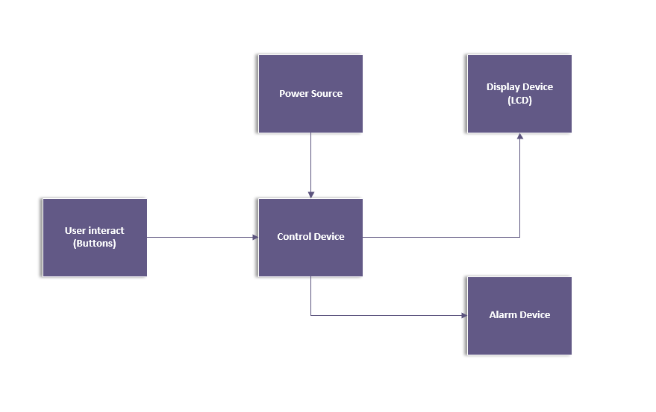

Figure 1. Overview block diagram

* 1. Operation environment

Operating environments for the digital watch are houses, offices, shops, and hotels.

* 1. Design and Implementation constraints
* Software layer design
* Hardware components selection

1. System Features
   1. Functional requirements
      1. REQ_PO3_DGW_CYRS_01_V02

**#imp SW**

The user can navigate between three modes (Display time, Stopwatch and Alarm) using MODE button.

* + 1. REQ_PO3_DGW_CYRS_02_V02

**#imp SW**

Display Time Mode:

The system displays time in HH: MM: SS AM/PM format (Display Time mode) when current mode is Stopwatch mode and mode is changed, or when system is powered-up.

* + 1. REQ_PO3_DGW_CYRS_03_V02

**#imp SW**

Adjust Time:

In Display Time mode, REQ1 button is used to select between adjusting hours, minutes, and AM/PM.

* + 1. REQ_PO3_DGW_CYRS_04_V02

**#imp SW**

In Display Time mode, when hours’ field is selected, REQ2 button is used to increment hours.

* + 1. REQ_PO3_DGW_CYRS_05_V02

**#imp SW**

In Display Time mode, when minutes’ field is selected, REQ2 button is used to increment minutes.

* + 1. REQ_PO3_DGW_CYRS_06_V02

**#imp SW**

In Display Time mode, when AM/PM field is selected, REQ2 button is used to change between both.

* + 1. REQ_PO3_DGW_CYRS_07_V03

**#imp SW**

In Display Time mode, to apply adjustments, press REQ1 button for confirming the modification of time.

* + 1. REQ_PO3_DGW_CYRS_08_V02

**#imp SW**

Alarm Mode:

The system shows the current time in HH:MM:SS AM/PM format until Alarm time is reached (Alarm mode) when current mode is Display Time mode and mode is changed.

* + 1. REQ_PO3_DGW_CYRS_09_V02

**#imp SW**

Set Alarm:

In Alarm mode, REQ1 button is used to select between adjusting hours, minutes, and AM/PM for alarm time.

* + 1. REQ_PO3_DGW_CYRS_10_V01

**#imp SW**

In Alarm mode, when hours’ field is selected, REQ2 button is used to increment hours.

* + 1. REQ_PO3_DGW_CYRS_11_V01

**#imp SW**

In Alarm mode, when minutes’ field is selected, REQ2 button is used to increment minutes.

* + 1. REQ_PO3_DGW_CYRS_12_V01

**#imp SW**

In Alarm mode, when AM/PM field is selected, REQ2 button is used to change between both.

* + 1. REQ_PO3_DGW_CYRS_13_V01

**#imp SW**

In alarm mode, to apply adjustments, press REQ1 button for confirming the modification of alarm.

* + 1. REQ_PO3_DGW_CYRS_14_V01

**#imp SW**

Buzzer:

In Alarm mode, the Buzzer is triggered with notification when alarm time is reached.

* + 1. REQ_PO3_DGW_CYRS_15_V01

**#imp SW**

In Alarm mode, the user stops buzzer alarm with REQ2 button.

* + 1. REQ_PO3_DGW_CYRS_16_V01

**#imp SW**

Stopwatch Mode:

The system displays a counter with initial value of 00:00:00 (Stopwatch mode) when current mode is Alarm mode and MODE is changed.

* + 1. REQ_PO3_DGW_CYRS_17_V01

**#imp SW**

In Stopwatch mode, REQ1 button is used to start counting every second if system was in paused state.

* + 1. REQ_PO3_DGW_CYRS_18_V01

**#imp SW**

In Stopwatch mode, REQ1 button is used to stop counting if system was in running state.

* + 1. REQ_PO3_DGW_CYRS_19_V01

**#imp SW**

In Stopwatch mode, REQ2 button is used to reset counter to 00:00:00.